**Software Process Selection and Project Plan**

**P02:Baichday**

|  |  |
| --- | --- |
| **Student ID** | **Name** |
| **23100181** | **Nashit Iftikhar** |
| **23100089** | **Mahad Mubashir Beg** |
| **23100157** | **Moiz Nafey** |
| **23100225** | **Muhammad Arslan Ullah Tarar** |
| **23100334** | **Silal Anwar** |

|  |  |  |
| --- | --- | --- |
| **Content** | **Totals** | **Obtained** |
| Software Process Selection | 25 | 25 |
| Project context analysis | 10 | 10 |
| Gantt chart | 25 | 10 |
| Development environment preparation | 20 | 20 |
| Deployment platform | 10 | 10 |
| Who did what | 3 | 3 |
| Review checklist | 2 | 2 |
| Overall formatting/template | 5 | 5 |
| Late submission penalty | -20 |  |
| **Total** | **100** | **85** |
| Review | 20 |  |
| **Grand Total** |  |  |

**Table of Contents**

1. Introduction 3

2. Software Process Selection 4

3. Gantt Chart 5

4. Risk Management 5

4.1 Potential Risks and Mitigation Strategies 5

5. Development Environment Preparation 6

6. Deployment Platform 6

7. Who Did What? 7

8. Review checklist 7

# Introduction

Pakistan is a huge country with a population numbering in the millions, yet the GDP of Pakistan remains rather low as compared to its massive population. We aim to facilitate the people of Pakistan by presenting our auction system. Our software will allow people to auction off their belongings to interested parties. Currently there exists no such platform that supports auctioning as a mechanism. In the status quo, people must spend valuable time and effort searching for customers to purchase their goods at a decent price. We aim to bridge this divide and bring value to the economy of Pakistan by solving this problem.

This software will target both businesses and individuals in the Pakistani context. Small scale businesses currently do not have a platform to bid for resources, and shipments. A small-scale mobile phone retailer finds it very inconvenient to currently bid for a shipment of mobile phones and similarly, repair shops face the same issue with car spare parts. Our auction system will allow wholesalers to enter their products for retail vendors to bid on. This has the potential to facilitate both wholesalers and the retail industry of Pakistan. Likewise, on a more individual scale, people with valuable assets are unable to put up their goods for the best price and must sell at the highest customer they manage to find. Our model will allow these users to list their belongings and allow bidding on it for the user to find the best price they can get from their belongings.

Our software will function similar to an ecommerce marketplace but with the added functionalities of timed biddings, scheduling of bids and other functionalities that will make the auction system a good and worthwhile experience for the users we target.

# Software Process Selection

< (1) Discuss a pros and cons of waterfall and agile (scrum) processes in your own words.

(2) Select one of the above processes for your project development.

(3) Justify your selection with clear reasoning. Refer to “Project Context Analysis” in the slides to get help for writing this section.>

Waterfall and Agile models are the two most commonly used software development methods. Since we are going to start the development phase of our project, we need to analyze the pros and cons of both models and choose the one that is best for us. The waterfall model is a sequential process which follows the 5 basic phases of development that are:

1. Requirements
2. Design
3. Implementation
4. Verification
5. Maintenance

Everything in the waterfall model is done step by step and requires documentation at every phase of the development process.

|  |  |
| --- | --- |
| **Pros:** | **Cons:** |
| 1. Since documentation is a significant part of the waterfall model hence it helps everyone in clearly understanding the objectives and also allows new developers to understand the project quickly if they join at a later stage. | 1. It does not allow for flexibility. Making changes to the requirements is not possible once you move on to the next phase. |
| 1. Helps maintain timelines and makes it easy to make sure that each phase is completed on time. | 1. Projects may take longer to deliver as steps are linearly followed. |
| 1. Testing is easy to do as test scenarios are already explained in the functional specification of the requirements phase. | 1. If initial requirements are faulty the problem is reflected on the entire project as it heavily relies on the requirements. |
| 1. The outcomes are clearly communicated through documentation and everyone is on the same page. | 1. It requires complete knowledge of the field that the project caters to as making changes later on is not possible. |
| 1. Workarounds of potential development issues can be handled during the design stage before actual development begins. | 1. It is only suitable for small-scale projects as large-scale projects often require changes. |
| 1. Size and cost of the project is pre-calculated. There is no uncertainty or surprises that can occur. | 1. It is difficult to estimate the time and cost for each stage of the model. |

The agile method on the other hand is an incremental approach and is also considered as a solution to the drawbacks of the waterfall method. Developers can work on small units on a weekly or monthly basis and it also allows for project priorities to be re-evaluated which is not possible in the waterfall model. It follows the following steps in every sprint:

1. Plan
2. Design
3. Build
4. Test
5. Review
6. Launch

|  |  |
| --- | --- |
| **Pros:** | **Cons:** |
| 1. It is a flexible model and allows to make changes even after the initial planning. | 1. It might cause unexpected delays in delivery of the project. |
| 1. It also allows to add features that keep you updated with advances in the industry. | 1. The project cost may go over budget as changes are being made overtime. |
| 1. It allows clients to give regular feedback to the developers and get the product they want. It promotes better communication. | 1. If the initial plan is not stable then the final project may turn out to be different than what was intended. |
| 1. The product gets to the market faster as the focus is on developing working deliverables and not perfect deliverables. |  |
| 1. It allows for regular testing. |  |

We will be following the agile methodology for the development of our project. The reasons for choosing agile method are listed as follows:

1. It is a small-scale project hence agile method allows us to add features overtime.
2. We have a small team of 5 people and all the team members are completely aware of what we aim to achieve hence we don’t require rigorous documentation at every stage.
3. Moreover, we are on a short timeline as we will have one and a half semester to complete our project so our goal is to produce working deliverables in shorter time spans instead of trying to develop a perfect deliverable at the end.
4. Since we are new developers with less work experience and are particularly new to this niche so we might need to make changes while developing and would need great flexibility there hence we cannot use the waterfall model.
5. Agile method allows for constant improvement in our project without any restrictions as we aim to deliver our project to the best of our abilities.
6. As [Agile teams](https://kissflow.com/project/agile/agile-team/) are self-organized and self-managing, they have increased autonomy and authority over their decisions and allows every team member to learn and grow in their respective roles.
7. It also allows us to track and evaluate our progress through the deliverables that we produce.

# Gantt Chart

[You did not identify the role of the individual team members in the plan. ]

The Link for our gantt chart is added below as the size of the gantt chart was not allowing us to add it inside the document. Please open the link below to view our gantt chart.

https://drive.google.com/drive/folders/1UfbkocqSaHZg5egtmuzyoLqH8XiKKWai?usp=sharing

# Development Environment Preparation

List of tools and technologies for prototype development:

* VS Code
* MongoDB Atlas
* Postman
* Reactjs
* Nodejs
* Expressjs
* MongoDB

The environment is set up and the prototype has been initiated. Following are the snapshots of the tools that will be used for the development purpose.

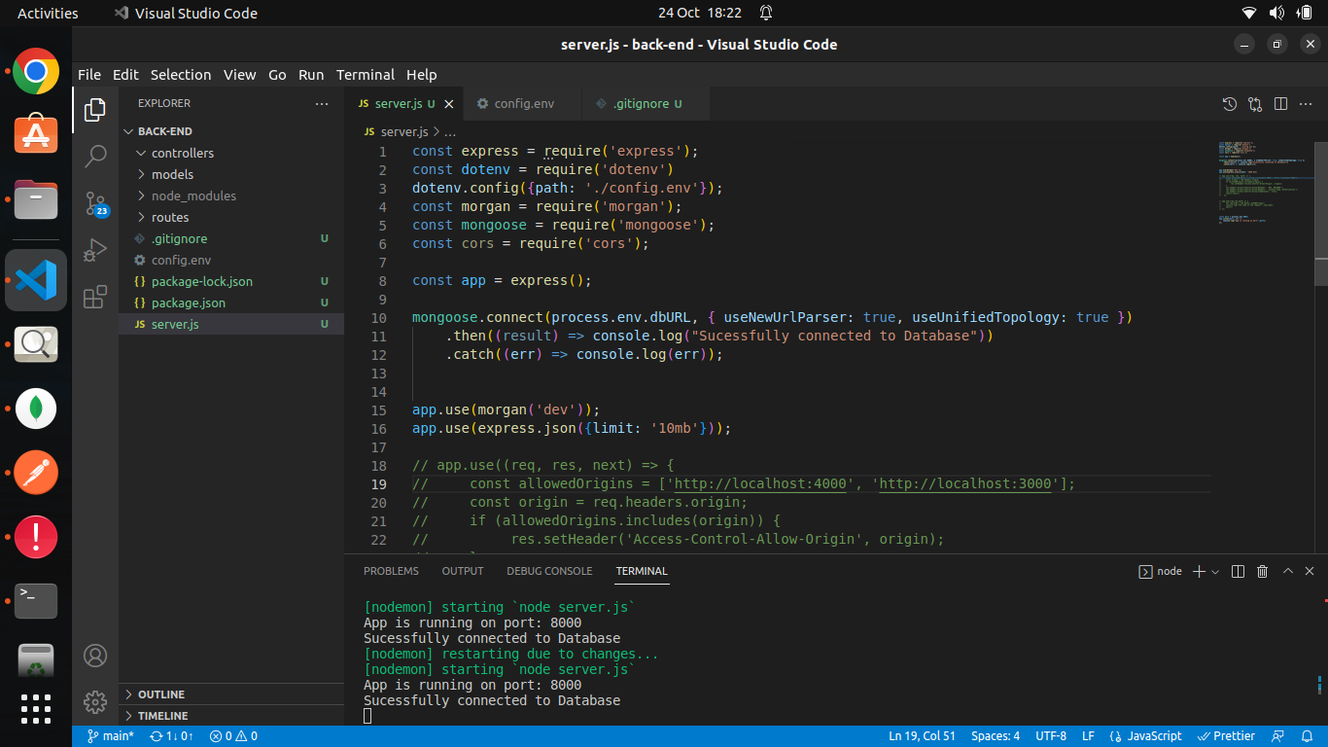

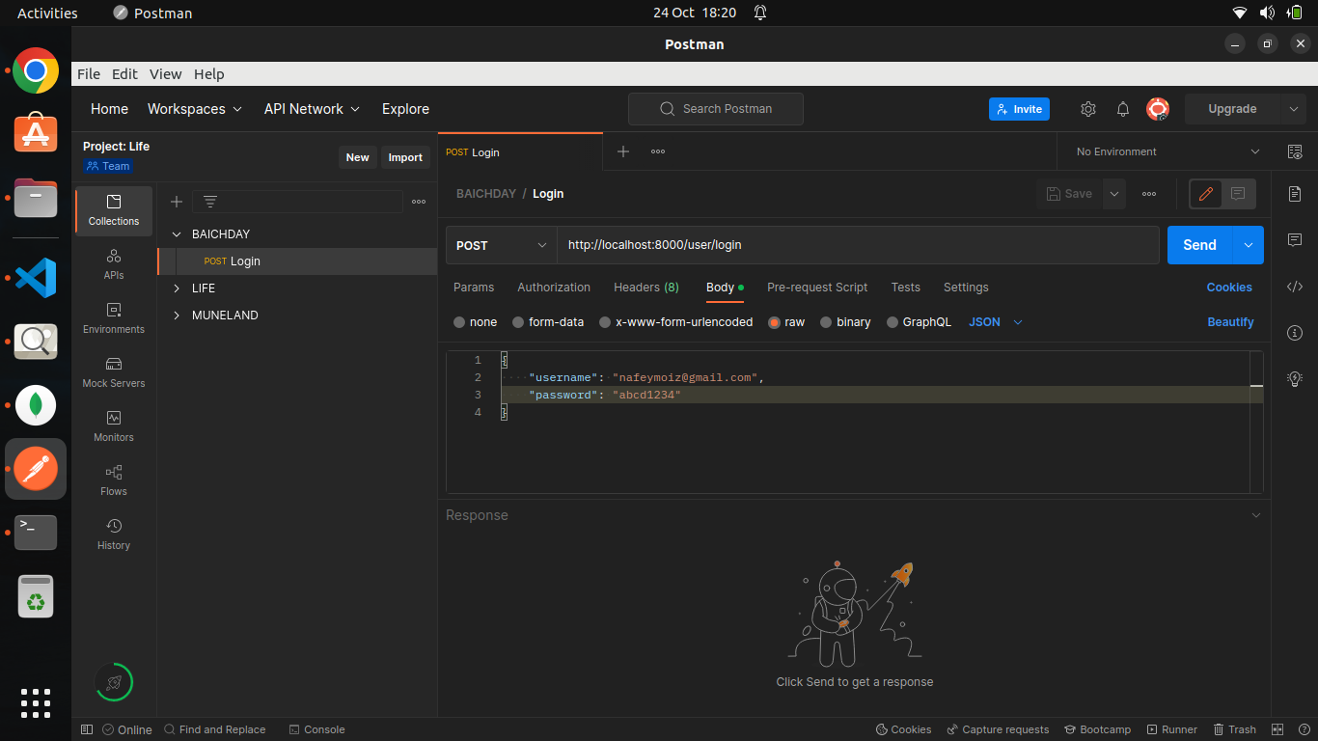

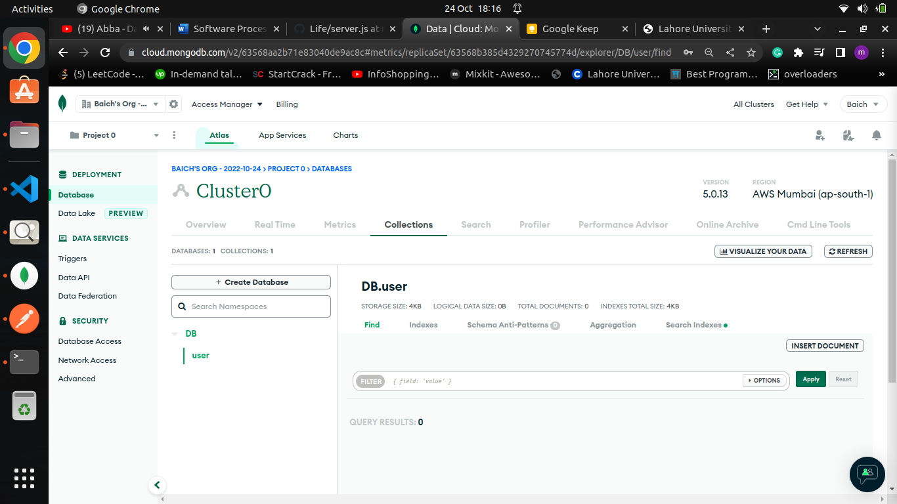

# Deployment Platform

|  |  |
| --- | --- |
| **Deployment Component** | **Free Hosting Service** |
| Front-End | Netlify |
| Back-End | Heroku |
| Database | MongoDB Atlas |

# Who Did What?

|  |  |
| --- | --- |
| **Name of the Team Member** | **Tasks done** |
| Mahad Mubashir Beg | 2. Software Process Selection |
| Moiz Nafey | 4.Development Environment Preparation |
| Muhammad Arslan Ullah Tarar | 5. Deployment Platform |
| Silal Anwar | 1. Introduction |
| Nashit Iftikhar | 3. Gantt Chart |

# Review checklist

Before submission of this deliverable, the team must perform an internal review. Each team member will review one or more sections of the deliverable.

|  |  |
| --- | --- |
| **Section** **Title** | **Reviewer Name(s)** |
| Software Process Selection | Moiz Nafey |
| Development Environment Preparation | Muhammad Arslan Ullah Tarar |
| Deployment Platform | Mahad Mubashir Beg |
| Gantt Chart | Silal Anwar |
| Introduction | Nashit Iftikhar |